Name: Gerardo Gonzalez.

Institution: Southern New Hampshire University.

Date: 2023/09/07 4:36 PM EST

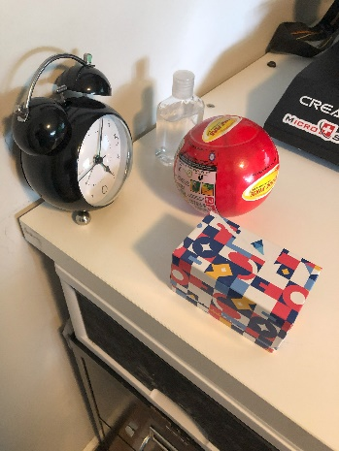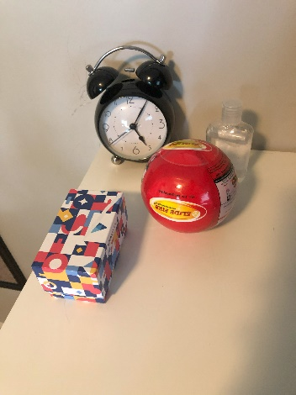Course: CS-330 Comp Graphic and Visualization.

The objects that I have chosen to create are a red ball, a clear bottle of hand sanitizer, and an abstract graphical small gift box. These objects are good choices as they all have four out of the six primitive shapes. I have attached a picture of the outlined shapes that can be interpreted. They also have a good set of color, and textures, to demonstrate when reconstructing.

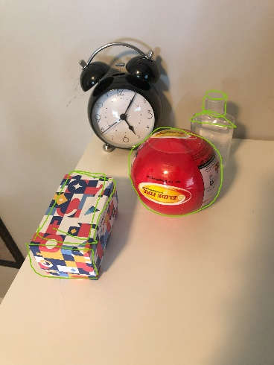The attached picture will outline where you can find a pyramid outlined with a green triangle and a green cylinder on top as the top half of the sanitizer bottle, while the bottom can be composed of a single cube. Then the red ball can be made out of a single sphere outlined with a green circle. The gift box can be composed of two cubes, one for the top half and one for the bottom half with the bottom half being smaller than the top half, also outlined with green squares. These are the four shapes that were mentioned earlier and if time permits I will attempt as a bonus challenge to reconstruct the clock.